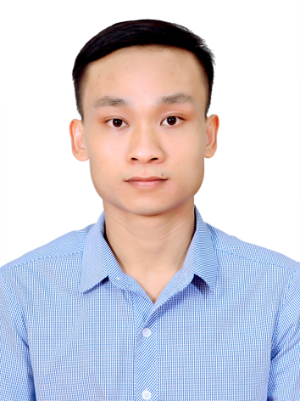
LE DUC HUY

Applying Position: QA staff
CONTACT INFORMATION
Full name: Le Duc Huy
Date of birth: 18/09/1990
Sex: Male
ID card No: 031537403
Address: Thien Kha, Tien Cuong, Tien Lang, Hai Phong
Mobile: 034.456.9966
Email: huy33391@gmail.com

CAREER OBJECTIVE
I wanted to become Leader QA Engineer, success in a professional company, where I can assert itself, contribute knowledge and experience to his the success of the KYOCERA Document Technology Vietnam company.

WORK EXPERIENCE
- 06/11/2017 to 25/8/2019: Rorze Robotech.
Position: QA staff

- Manage the performance of inspection staffs based on excel and 7 QC tools
- Improve productivity and reduce errors for inspection staffs
- Perform other management tasks as required by the Production assistant manager
- 26/8/2019 to PRESENT: LG Electronics Việt Nam Hải Phòng.
Position: QA staff

- Co-work with related team for quality issue resolving
- Analyze quality defect, reliability defect
- Report quality issues with my Team Leader weekly
- 4M change management
- Perform other management tasks as required by my Team leader
EDUCATION
- 10/2008 – 05/2012 Vietnam Maritime university with a good engineer degree. (Specialty: Naval Architect).

HONORS & AWARDS
- Scholarship in 1st semester 2010 – 2012.

PROFESSIONAL SKILLS
- I have 4 years experience about QA staff.
- Able to program macro by VBA on Excel, PowerPoint to automatic some my job
- Able to read engineering drawings.
- Computer software very proficiency: AutoCAD 2D, AutoCAD 3D, Excel, PowerPoint, Word.
- Can use 2D measuring equipment proficiency: Caliper, Panme,…
- I have knowledge of 5S, safety, ISO, 4M, 7QC tool skills, IATF16949, improvement skills.
- Good command in English.
- Good communication and presentation skills.
- Able to work independently and within a team under pressure.
- Creative, high discipline.
- Quick-learner, self-confident and active.
- Hard working, well-organized and high sense of responsibility.
HOBBY
- I like jogging, workout with my friends.
- I like learn Japanese also.

